**Can you convert a VM into ISO file?**

**Case:**

I have been working on a virtual machine for work, and I am wondering is there a way to convert a VM to an ISO file so that I could use this outside of a virtual environment, on a physical computer?

- Question from www.reddit.com

As you may know, VMware Virtual Machine Disk files (VMDK) basically cover all VM data, and can be used to clone VMware virtual machines. However, they cannot be recognized by Windows.

If you want to transfer all of your VM data to a physical machine, you may want to know if there is a way to convert VM to ISO image, which can be installed on any virtualization platform, as well as on bare metal.

[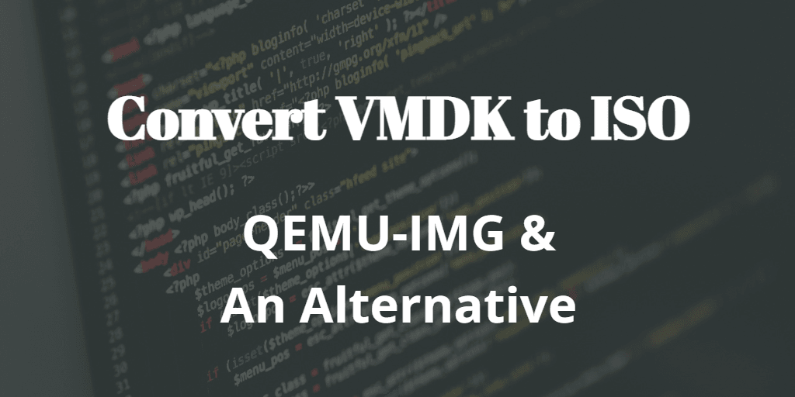](https://www.ubackup.com/screenshot/en/acbn/others/vm-to-iso/convert-vmdk-to-iso.png)

Unfortunately, there are few ways to do this. If you are using Linux, then you can convert VMDK to ISO by using dd and qemu-img commands. But if you are using Windows, you will need to resort to third party software.

Actually, if you just want to perform V2P conversion, there will be more choices. For example, you can backup the system and restore it to a physical machine. I will introduce how to convert VM to ISO and V2P conversion both in this article.

**How to convert a VM into ISO file via QEMU-IMG command**

1. Install and put both dd and qemu-img program in the system path. Open a **Command Prompt** window in the folder where the source VMDK file is, and run the following commands to convert the source VMDK file to raw image.

qemu-img convert -f vmdk **filename**.vmdk **filename**.raw

2. And then run the following command to convert the raw image to ISO file.

dd if=**filename**.raw of=**filename**.iso

**Note**: replace **filename** with the file name of your VMDK file.